📊 Evaluation Report: AI Paraphrasing Tool
🎯 Objective
The objective of this project is to evaluate the performance of an AI-based paraphrasing tool in terms of:
- Accuracy (meaning preservation)
- Originality (degree of rephrasing)
- Fluency (grammatical correctness and readability)

🧪 Evaluation Methodology
A set of test sentences with varying complexity (simple, moderate, and complex) were given as input to the model:
- Model used: humarin/chatgpt_paraphraser_on_T5_base
- Total samples tested: 10–20 sentences
- Evaluation type: Manual + qualitative analysis
Each output was evaluated based on:
Metric | Description
Accuracy | How well the meaning is preserved
Originality | How different the output is from input
Fluency | Grammar and readability

🖼️ Sample Output / Result Visualization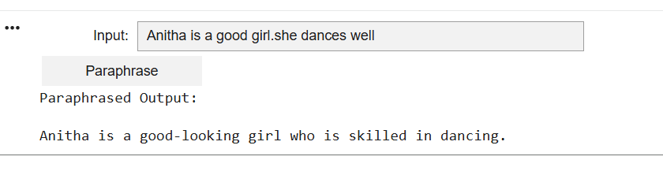
⚠️ Observations
- Performs well on simple sentences
- Limited paraphrasing for complex inputs
- Sometimes only minor word replacements

🚀 Suggestions for Improvement
- Use advanced models (Pegasus, T5-large)
- Generate multiple paraphrases
- Add diversity control
- Include BLEU / ROUGE evaluation

✅ Conclusion
The AI paraphrasing tool produces accurate and fluent outputs, with a reasonable level of rephrasing. It works well for general-purpose sentence paraphrasing.

